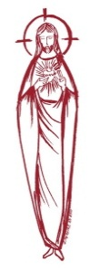
SACRED HEART PARISH

Sacred Heart Parish Founded 1814, The First Catholic Parish in the STate of New Jersey

Sacred Heart Church, 343 South broad Street, Trenton, New Jersey 08608

Holy Cross Church, 233 Adeline Street, Trenton, New Jersey 08611

ALL ARE WELCOME

Whatever your present status in the Catholic Church, whatever your current family or marital situation,

Whatever your past or present religious affiliation, whatever your personal history, age, background, or

race, whatever your own self-image or esteem, you are invited, welcomed, accepted, loved and

respected at the Parish of the Sacred Heart.

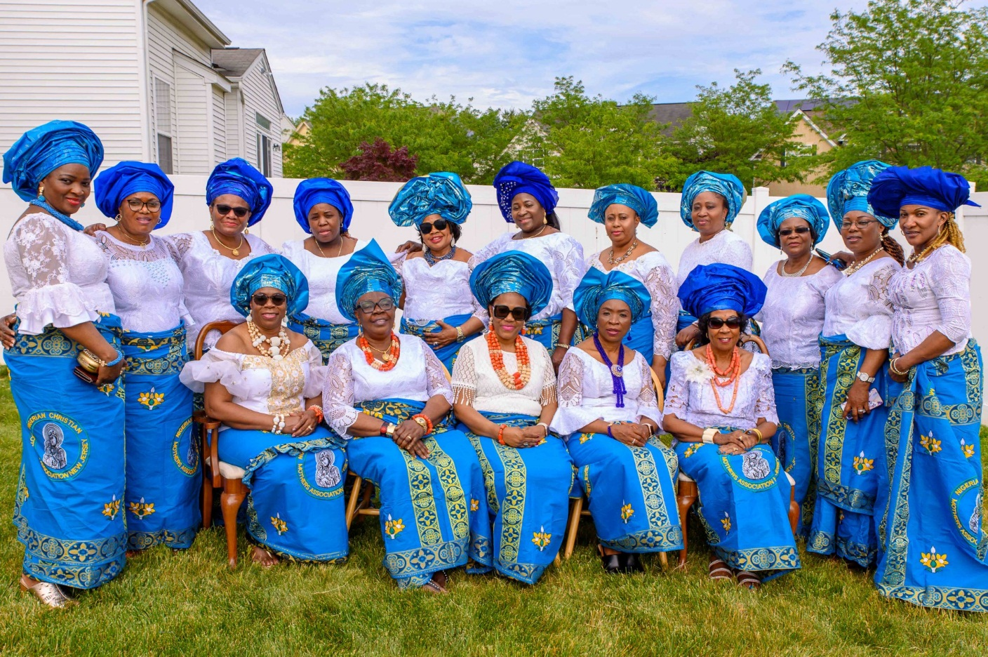

CONGRATULATIONS TO THE

NIGERIAN CHRISTIAN MOTHERS ASSOCIATION

Celebrating their Inauguration Mass

In Sacred Heart Parish

at Holy Cross Church

July 30, 2023

Seventeenth Sunday in Ordinary Time
July 30, 2023
MASS INTENTIONS
Saturday, July 29
4:00 pm ~ Charlene A. Kuzma
5:15 pm SHC ~ Special Intention
Sunday, July 30
9:00 SHC ~ John Matthews
10:00 HCC ~ Nigerian Christian Mothers Association
11:15 ~ Anella Ferrara & Miraldo Family and Marie Jaeploe
12:00 HCC Polish ~ The intentions of the People of the Parish
Monday, July 31
8:00 am HCC ~ Special Intention
12:10pm SHC ~ Mrs. Kathryn Pobuta
Tuesday, August 1
12:10 pm SHC ~ Gunnar Szul
Wednesday, August 2
12:10 pm SHC ~ Mike Scartocci and Catherine Giallella
Thursday, August 3
8:00 am HCC ~ For Vocations
Friday, August 4
8:00 am HCC ~ Eileen Kostrzewa
12:10pm SHC ~ For the Sick
Saturday, August 5
4:00 pm ~ Thomas “Red” Olszewski and Christopher Kurilla
5:15 pm SHC ~ Ken and Lucille Fisher
Sunday, August 6
9:00 SHC ~ Sarandrea and Tagliaferri Families
10:00 HCC ~ The intentions of the People of the Parish 11:15 SHC ~ Maria Paullette Drain
12:00 HCC Polish ~ Zbigniew Kolodziej

OUR SICK LIST
Steve Jurczynski, Trudy Breuer, Cornell Hess, Carole Minotti, Ruby Covington, Judith Santigo, Ching Kukis, Dan Breese Jr, Brenna Kennedy-Moore, Dawn Chia, Mark Friedman, Robert Leighton, Patrick Leighton, Alexander A. Ladnyk, Kelly Nitti, Lauren Clayton, Joseph Edralin, Margie Tiongson, Kevin, Vincent Cooper, Jr., Gail Ladnyk, Leo Genovesi, Sloane Donnelly, Richard Buckley, Tony Ragolia, Barbara Burrows, Robert Mahon, Charles Burrows, Dorothy Amoroso, Maryann Sullivan, Regina Friedman, Rita Mich, Stanley Winowicz, Greg Schafer, Jack Hardiman, Paul Leighton, Amy Birk, Julia Grazioli, Matt and Leona Tydryszewski.

OUR DECEASED

Rita Woods, Geraldine Mangini and our friends at South Village, Riverside Nursing and Rehabilitation Center, Mill House and Waters Edge.

MINISTRY SCHEDULE
(subject to change)
Saturday, July 29
4:00pm HCC ~ Fr Charles L. C Benitez Em. A Lennon
5:15pm Msgr. Dennis L. L Seabrook Em. J Breuer. B DuMont
Sunday, July 30
9:00 SHC ~ Msgr. Dennis L.K Valentino, Em K F & E Zielinski
10:00 HCC ~ Fr. Charles l. R Nnajiofor, Em G Mowenn
11:15 SHC ~ Msgr. Dennis L. M Rogers Em K Parasimo A Woloff
12:00 HCC Polish ~ Fr Marian

Saturday, August 5
4:00pm HCC ~ Fr Charles L. M Herpel Em. N Saganowski
5:15pm SHC ~ Msgr. Dennis L. L Bellina, Em. T Hines, W Lewis
Sunday, August 6
9:00 ~ Msgr. Dennis L. E Wengryn, Em H Mangan J Mc Donough
10:00 HCC ~ Fr. Charles l. I Nwachukwu Em S Nwachukwu
11:15 SHC ~ Msgr. Dennis L. J Rhodes Em N Rhodes B Allaire
12:00 HCC Polish ~ Fr Charles

WEEKLY COLLECTION
Last weekend’s collection amounted to $7,612.00 and for Priest Retirement Fund $2,423.00. This includes the donations received in Church and the mail ins. Thank you for your continued support of our parish.

2023 ANNUAL CATHOLIC APPEAL UPDATE
Goal: $33,000.00 : Pledged: $43,896.00 (133% of Goal)

READINGS FOR THE WEEK
Seventeenth Week in Ordinary Time
Sunday 1 Kgs 3:5, 7-12; Rom 8:28-30; Mt 13:44-52 or 13:44-46
Monday Ex 32:15-24, 30-34; Mt 13:31-35
Tuesday Ex 33:7-11, 34:5b-9, 28; Mt 13:36-43
Wednesday Ex 34:29-35; Mt 13:44-46
Thursday Ex 40:16-21, 34-38; Mt 13:47-53
First Friday Lv 23:1, 4-11, 15-16, 27, 34b-37; Mt 13:54-58
Saturday Lv 25:1, 8-17; Mt 14:1-12

PROMISE TO PROTECT
The Diocese of Trenton is committed to the norms of the U.S. Bishop’s Charter for the Protection of Children and Young People in regard to the reporting and investigation of sexual abuse allegations involving minors. If you have been sexually abused as a minor by anyone representing the Catholic Church, you can report that abuse through the diocesan Hotline: 1-888-296-2965 or via e-mail at abuseline@dioceseoftrenton.org. Allegations are reported to the appropriate law enforcement agencies.
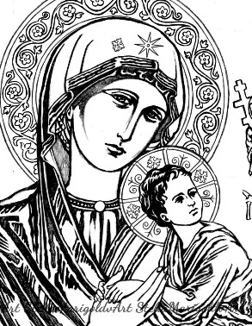
NIGERIAN CHRISTIAN MOTHER’S ASSOCIATION
The Nigerian Christian Mothers are a group of women from our general area who began their association a while ago as a Christian Prayer Group. They gathered together for prayer, under the guidance of the Blessed Virgin Mary. During their prayer time they sought friendly advice from their ‘sisters’ in regard to family situations, difficulties in life and advice with family concerns.
Today, they celebrate their Inauguration Mass as an Association, seeking the Blessing of the Church. They will continue as an association to adhere to family values and share these virtues with each other and their families, with a special emphasis on their children. As a part of their ministry they will commit themselves to reaching out to the needy both in our area and in Nigeria.
We congratulate these Christian Women for their great example of Spirituality and for sharing their values and treasures with all.
SCHOOL SUPPLY COLLECTION
This year we will be collecting school supplies for the children in our neighborhood who are in need of assistance. Please bring your gifts to the altar on the weekend of August 12th & 13th. All school supplies from back packs to pencils are acceptable. Thank you.

WELCOME SISTER ELLA MAE
RELIGIOUS TEACHERS FILIPPINI
The Pontifical Institute of the Religious Teachers Filippini is an Institute of consecrated life dedicated to the works of the Apostolate. Faithful to the original inspiration of our Founders, St. Lucy Filippini and Cardinal Mark Anthony Barbarigo, we continue to regard the ministry of the Christian education of youth and of adults, especially women, as our principal duty. Impelled by our mandate to “go and teach the Word of God” we, the Religious Teachers Filippini, re-affirm our commitment to Catholic Education, making the Life and teachings of Jesus and His Church relevant in the lives of our students, so that they come to know and experience their true identity as sons and daughters of God, and be empowered to be Jesus for others, nurturing them to life in the Lord, enabling them to help build a world where justice and peace prevail.

SECOND COLLECTION THIS WEEKEND
Your generosity with the Religious Teacher Filippini Mission Appeal this weekend is greatly appreciated. Please support their ministry with your prayer as well.

SHOW YOUR SUPPORT
LIGHT OF HOPE HONOREE
We are excited to announce that Msgr. Dennis Apoldite is being honored as one of Catholic Charities Light of Hope honorees at their 2023 Guardian Angel Dinner Dance. Please show your support in honoring Msgr. Dennis by donating to Catholic Charities through the purchase of an ad, dinner ticket, or journal opportunities. More information is available by going to
www.CatholicCharitiesTrenton.org/GADD2023
Catholic Charities staff will be with us in a few weeks to offer you the opportunity to purchase 50/50 tickets for their organization. Donations can be made in any amount, payable to Catholic Charities, Diocese of Trenton P.O. Box 1423, Trenton NJ 08607

RCIA – BECOMING CATHOLIC
Are you interested in becoming a Catholic? The desire to draw closer to God is in all of us, for we are his creation. Do you know an adult who would like to find out about what we believe? Do you know anyone who has not completed the Sacraments of Communion and Confirmation, and would like to? Please prayerfully consider who might be interested in entering more fully into the Catholic faith and invite them to join us for our “Inquiry session” scheduled to begin in September. Please contact Msgr. Dennis at
Frdennis@trentonsacredheart.org or
609-393-2801 ext. 102.
NOW IS THE TIME TO REGISTER
Parents are asked to reregister their children on or before the last class. New Registration and Re-registration forms are available online or at the Parish Office. The tuition fee is $65.00 per child.
WEDDING ANNIVERSARY BLESSING
The Department of Evangelization and Family Life is pleased to announce the 2023 Bishop’s Anniversary Blessing for all couples celebrating a milestone anniversary of their Catholic Marriage. All couples celebrating their 1st, 25th or 50th (or more) anniversary in the 2023 calendar year are invited to attend. Anniversary couples must be validly married in the Catholic Church and registered members of a parish in the Diocese of Trenton. The Bishop’s Anniversary Blessing Mass for Mercer and Burlington County Parishes will be held on Sunday, October 22, 2023 at 3 pm in the Cathedral of St. Mary in Trenton. General information including online registration for anniversary couples can be found at www.dioceseoftrenton.org/bishops-anniversary-blessing.

The Prayer of Saint John Vianney
I love You, O my God, and my only desire is to love You until the last breath of my life. I love You, O my infinitely lovable God, and I would rather die loving You, than to live without loving You. I love You, Lord and the only grace I ask is to love You eternally. My God, if my tongue cannot say in every moment that I love You, I want my heart to repeat it to You as often as I draw breath.
EUCHARIST FOR THE HOMEBOUND
If you or someone you know is unable to come to Mass because of significant illness or long-term disability, Eucharistic Ministers will visit area homes to bring the Blessed Sacrament. This has been a church tradition since the 1st century. Please call Msgr. Dennis at the parish office to inform us, 609.393.2801.

RETROUVAILLE
Tens of thousands of couples have healed their marriages through Retrouvaille (pronounced Retro-vy). Couples learn to build communication skills and to increase intimacy. It provides help for marriage problems, difficulties or crises. The Office of Family Life, Diocese of Metuchen, will sponsor a Retrouvaille weekend on August 18-20. For further information, please contact Rich Colasuonno (732-236-0671) or Annette Colasuonno (732-672-0748) or email 3024@helpourmarriage.org. The Family Life Center in Malvern, PA will hold Retrouvaille weekends on August 18 - 20 and October 6 – 8. For more information, or to register, visit www.HelpOurMarriage.org or call 215-766-3944 or 800-470-2230. All inquiries are strictly confidential.
SAINT JOHN VIANNEY
Feast Day August 4
John Vianney, venerated as Saint John Vianney, was a French Catholic priest who is venerated in the Catholic Church as a saint and as the patron saint of parish priests. Wikipedia
Born: May 8, 1786, Dardilly, France
Died: August 4, 1859, Ars-sur-Formans, France
Parents: Matthieu Vianney, Marie Beluze
Canonized: 31 May 1925, Vatican City by Pope Pius XI
Feast: 4 August;
Major shrine: Shrine of St. John Vianney, Ars-sur-Formans, Ain, France

